

CSE 1004

Network and Communication

CLOSED ASSESSMENT

**NAME**: Vibhu Kumar Singh

**REG. NO**: 19BCE0215

**TEACHER**: Santhi H.

**Q1-a)** **Indian Bank at VIT campus has Loan, Credit, Direct banking and Customer care departments with 20 hosts, 16 hosts, 8 hosts and 10 hosts each along with a application server, web server and mail exchange server. All these servers have to be connected to the internet. Using CPT create the complete network infrastructure for the above given scenario by assigning any class of Private IP address. Simulate the designed network by exchanging simple messages between different network LAN segments. Also check whether the devices between different departments could reach each other. Display the raw statistics of the currently designed individual LAN.**

**Ans1-a)**

Handwritten (Steps and Interpretation of output):

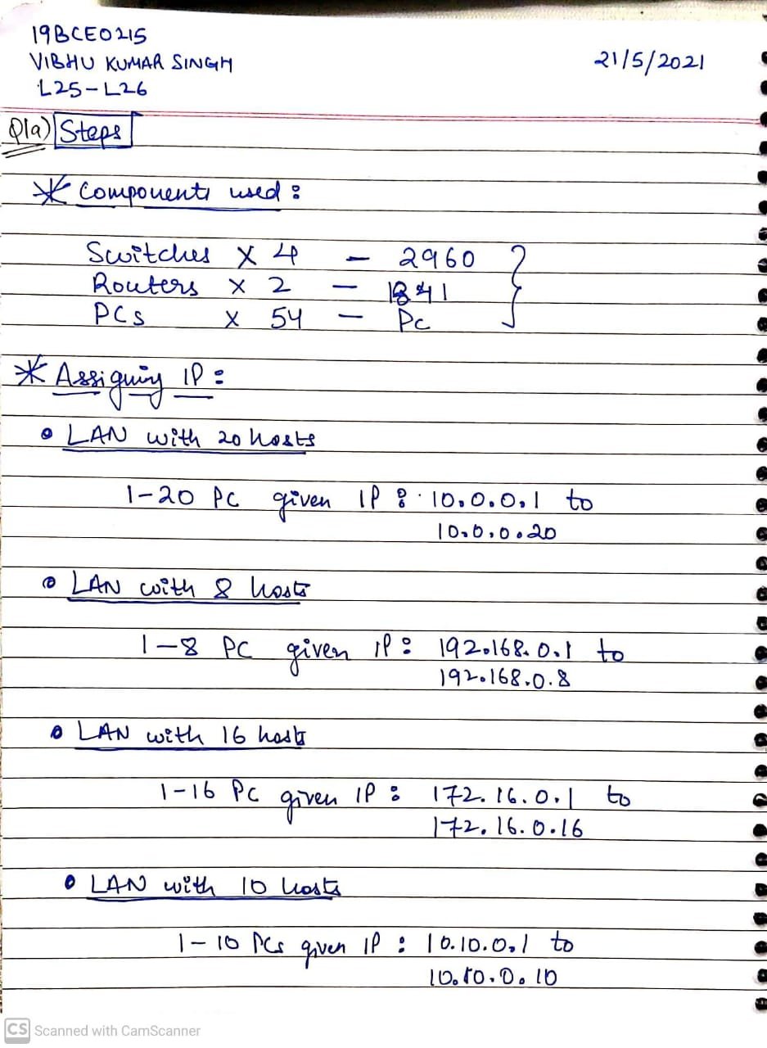

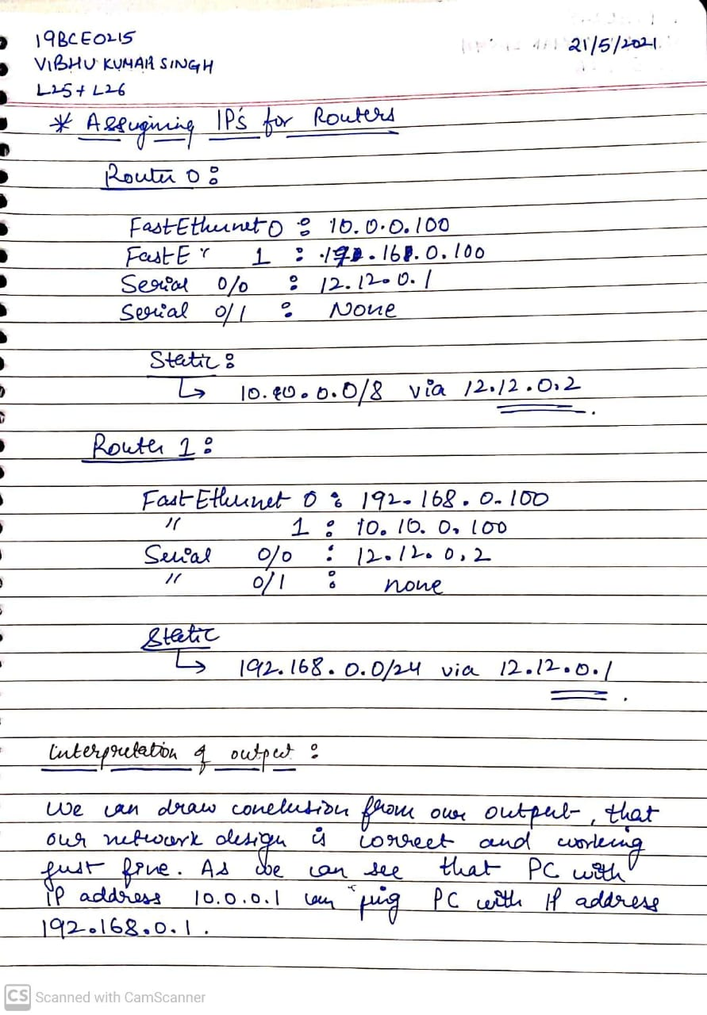

Screenshot of Network Design:

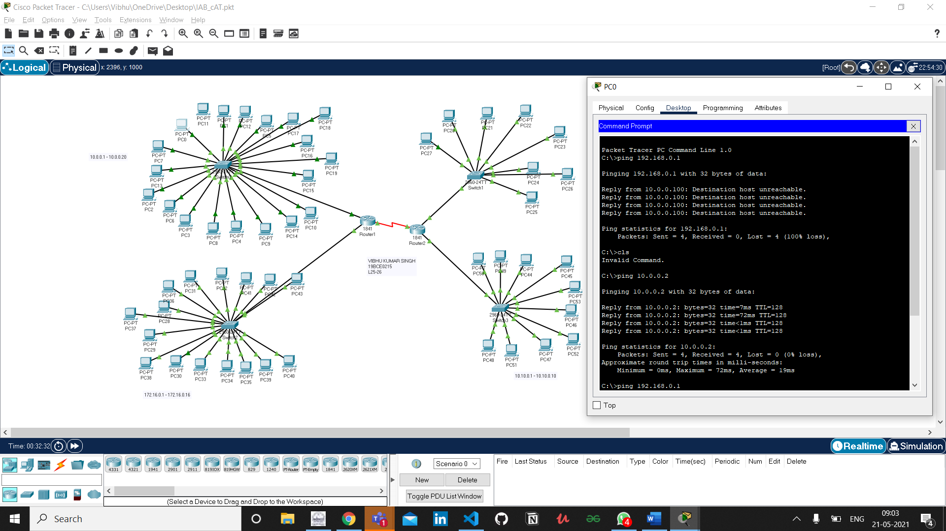

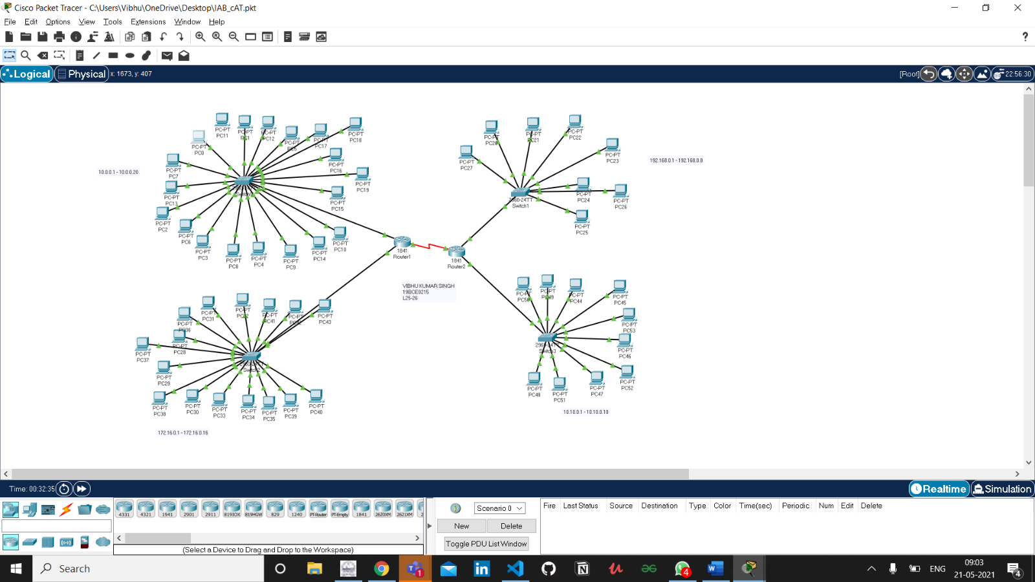

**Q1-b)** **Write a code to find the hamming code distance for any 4-bit sequence binary data. Input to the code is any SIX 4-bit sequence binary data at the runtime.**

**Ans1-b)**

Handwritten (Algorithm and Source Code):

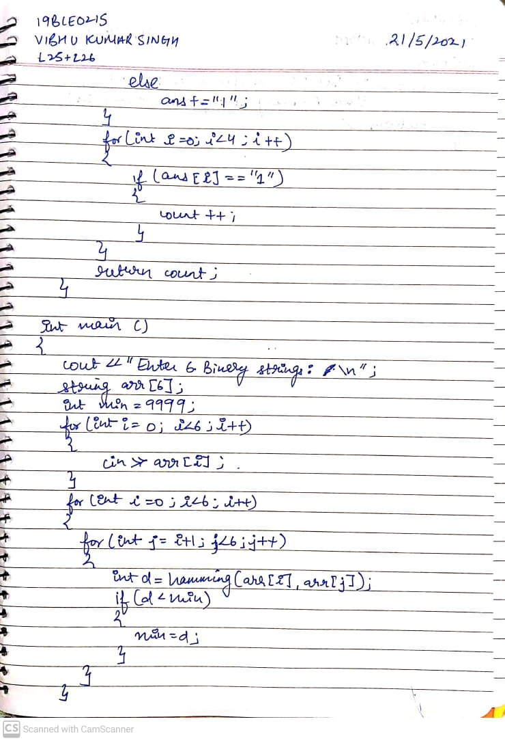

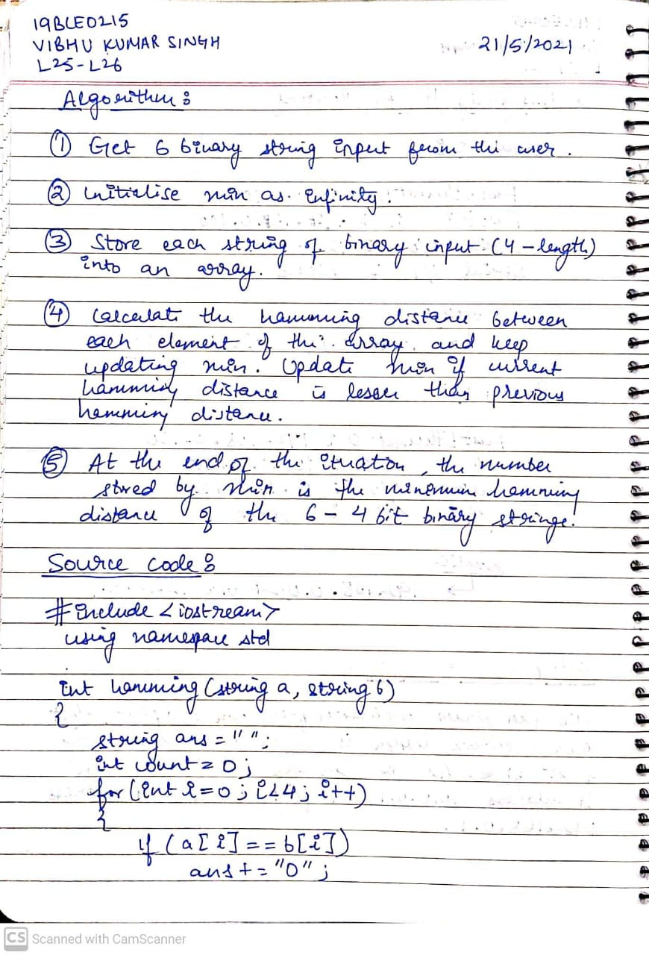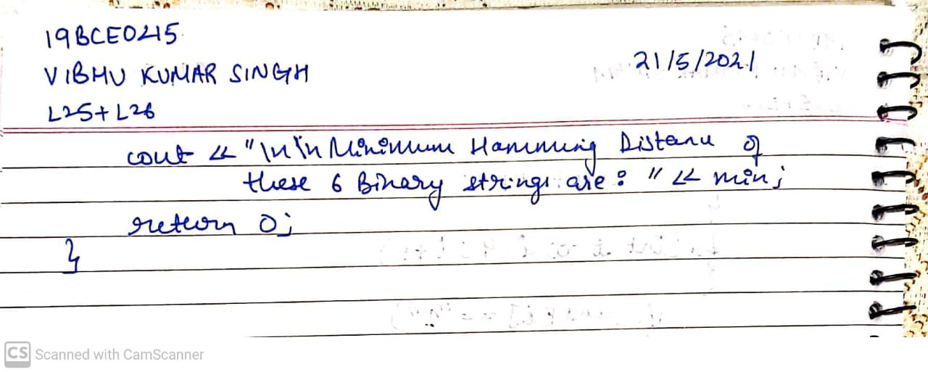

Screenshots:

